Writing Task 1
Muhammad Umar Farooq

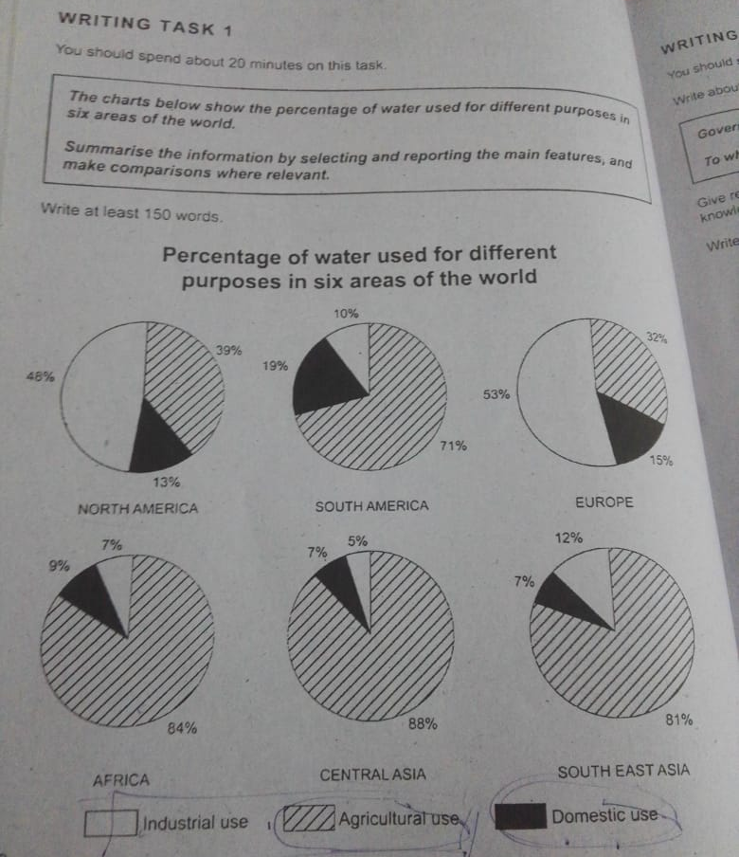
The provided charts illustrate the percentage of water used in Domestic, Agriculture, and industries in six significant areas over the globe.
Overall, North America and Europe showed the higher water usage in Industries while, all the other regions demonstrated the water consumption in Agriculture over the globe.
Looking at the details, North America had the 48% water utilization in Industries while, Europe is the second in this category who use 53% of water in Industries. Meanwhile, South East Asia, South America, Africa, and Central Asia had water depletion less than 12% overall.
Agriculture is most vibrant department in the word in which water expended is on the top. So, Central Asia is on peek of this list with 88% in contrast, Africa is also an agriculture region who use 84% water in crops. Thirdly, South East Asia handling 81% water so, according to this chart Asia is one of the best Farming Region. However, South America utilized 71%, North America 39% and Europe is on the last of the list of cultivation with 32% water usage.
Domestic water consumption is very minimal all over the six regions, South America is on the crest with 19% water consumption in domestic while, south east Asia with least water used with 7%. Moreover other four upsized between 15% to 7%.

